From The Desk of The Robotsmiths

Thank you for your Husky A200 order! As part of the integration, we have prepared this quick reference sheet for you and your team detailing your specific package.

System Operational Tips

For best battery performance and life, it is advised that the batteries be charged immediately after use. If the vehicle begins halting unexpectedly, doing one or more of the following may improve performance:

* Reducing motor power draw by lowering acceleration, turning in place less, or limiting the grade of terrain being traversed.
* Reducing peripheral power draw by unplugging or otherwise shutting off devices which are not in use.

Network Information

The wifi router in your Husky is configured as an Access Point. At any time, you may connect to the Husky’s radio via wifi, and your computer will be assigned an IP address via DHCP. To connect the Husky to the Internet, plug the “Internet” port on the top plate into a live Internet connection. You may also connect directly to the robot via Ethernet by connecting directly to an open port on the top plate.

| Parameter | Robot |
| --- | --- |
| Wifi Router SSID (2.4GHz) | A200-0398-2G |
| Wifi Router SSID (5GHz) | A200-0398-5G |
| Wifi Router IP | 192.168.1.10 |
| Wifi Router login | admin |
| Wifi Password (2.4/5GHz) | Clearpath |
| LMS11X IP | 192.168.1.14 |
| Husky Mini-ITX IP | 192.168.1.11 |
| Husky Mini-ITX hostname | cpr-a200-0398 |
| Husky Mini-ITX login | administrator : clearpath |

You may change the wifi router settings by accessing the router configuration pages through a web browser.

If your region requires different wifi frequency settings from North America, be sure to **change the regulatory domain**. To do so, log in to the router, choose the “Wireless” tab, then click the “Advanced Settings” checkbox. This will open additional settings. At the “Regulatory Domain” pull-down menu, choose your region. Do this for both the 2.4GHz and 5GHz interfaces. Finally, go to the bottom of the page and click the “Save” and “Apply Settings” buttons.

Software Information

* This system is pre-configured to start a joystick interface node for teleoperation. At any time, the wireless gamepad may be used to drive the Husky. Hold the “X” button for fast mode or “A” for slow, and steer with the left analog stick.
* The hardware launch script will run on startup. It can be started in the background with sudo service husky-core start and stopped with sudo service husky-core stop. It may be launched in the foreground using **sudo husky-core-start**. Your team should never need to start or stop the service—just use roslaunch to launch additional nodes which interface with the persistent ones. If you have to stop the service type **rostopic list** to make sure that all the nodes have been stop.

Remote Connection to Husky

For maximum compatibility, we recommend your ROS workstation be configured with ROS Indigo:

* Download and install Ubuntu Desktop 14.04 LTS from Ubuntu.com
* Set up ROS Indigo: <http://wiki.ros.org/indigo/Installation/Ubuntu>
* Install the Desktop packages for Husky:

$ sudo apt-get install ros-indigo-husky-desktop

To communicate directly with the Husky PC, you can SSH in. It will be necessary to ssh into the robot for tasks such as installing, modifying or removing software and files on the Husky. Note that you will not be able to use GUI tools such as rviz over an SSH connection. In the command prompt:

$ ssh administrator@cpr-a200-0398

In order to use rviz and other visualization tools, you must declare the Husky as master. In a console, type:

$ export ROS_MASTER_URI=http://cpr-a200-0398:11311

You should then be able to view a list of topics published by the Husky with:

$ rostopic list

It will be necessary to declare the Husky as master in every new terminal window, unless you change the master permanently in your ROS environment variables.

If you are able to see a list of topics but no data is being published, you may need to add the Husky to your computer’s /etc/hosts file. Add this line:

192.168.1.11 cpr-a200-0398

**Example Usage**

**GPS**

The GPS receiver in both robots publishes fix data to /gps:

$ rostopic echo /gps/fix

The raw data from the GPS receiver is available from the “nmea_sentence” topic:

$ rostopic echo /gps/nmea_sentence

**IMU(UM7)**

IMU (UM7) is installed in the Husky user bay in the following direction with respect to base_link:

X= 0

Y= - 180 mm

Z= + 75 mm

Values should be adjusted in the robot description configuration file.

You may use the following command for installing the UM7 driver:

$ sudo apt-get install ros-indigo-um7

**SICK LMS11X LIDAR**

You may verify that the LIDAR is publishing properly using the hz command. It should publish at roughly 50Hz. Visualize the data it produces using rviz.

rostopic hz /scan

**Remote Tele-Operation**

Full tele-operation of the Husky may be accomplished by installing the Husky core on your “base station” computer. Declare the Husky as master, then launch the teleop node in the command prompt:

$ sudo apt-get install ros-indigo-husky-robot

$ roslaunch husky_bringup teleop.launch

With the wireless gamepad dongle plugged into your base station computer, it should be possible to drive the Husky remotely. You may remotely view the image from the Husky camera using ROS.

**Visualizing the Husky in rviz**

The Husky may be visualized using rviz. The Husky Desktop package must be installed on your local computer (see **Remote Connection to Husky**, above). Also be sure to clone, build and source the wisu01_husky_customization package on your local computer, to ensure the meshes display properly in rviz. Then, simply connect to the Husky’s wifi network, and follow these steps:

1. Declare the Husky as ROS Master

$ export ROS_MASTER_URI=http:// cpr-a200-0398:11311

1. Source the custom workspace

$ source ~/catkin_ws/devel/setup.bash

1. Launch rviz

$ roslaunch husky_viz view_robot.launch

You can rotate the model using your cursor, and zoom in or out by scrolling up or down. Strafe by holding down Shift and dragging the model. The Husky itself may be driven directly from rviz by changing to interact mode. In this mode, arrows appear around the Husky model. Drag the arrows to make the Husky move.

A camera stream may be added to the rviz interface by clicking the “Add” button in the bottom left, then choosing the desired camera stream topic.

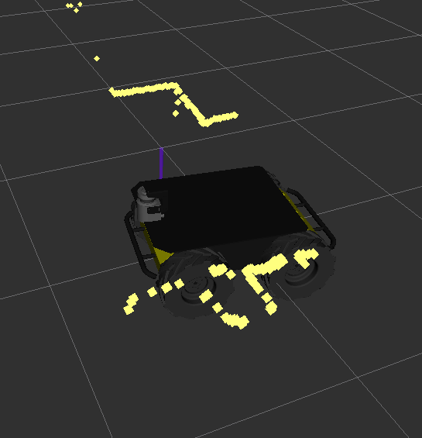

More information on rviz is available here: <http://wiki.ros.org/rviz>

Information on husky_viz is available here: <http://wiki.ros.org/husky_viz>

**Learning**

If you are new to using ROS, please visit our support page for information on how to get started using your new Husky:

support.clearpathrobotics.com

Please contact our support team directly at **support@clearpathrobotics.com** if you have any questions that aren’t answered on our support page. For ROS-specific questions, we recommend visiting **answers.ros.org**, which we also keep an eye on.

Sincerely,

The Robotsmiths